Exhibition Information
Show Name: | Beijing International Hydrogen Technology & Equipment Exhibition
Show Dates: | March 26-28,2025
Venue： | New China International Exhibition Center, Beijing
Sponsors: | China Energy Research Society  Zhenwei International Exhibition Group  Beijing Zhenwei Exhibition Co., Ltd.
Organizer: | Beijing Zhenwei Exhibition Co.,Ltd
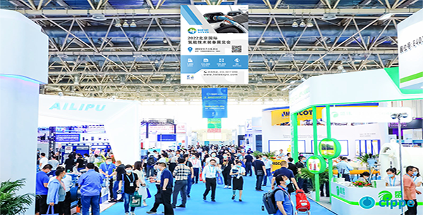
Concurrent Exhibitions: | The 24rd China International Petroleum & Petrochemical Technology and Equipment Exhibition (cippe)  The 24rd Beijing International Offshore Oil & Gas Exhibition (ciooe)  The 24rd Beijing International Exhibition on Equipment of Pipeline and Oil & Gas Storage and Transportation (CIPE)  The 24rd Beijing International Explosion Proof Electric Technology & Equipment Exhibition (Expec)  The 14th Beijing International Offshore Engineering Technology & Equipment Exhibition (CM)  The 14th Beijing International Natural Gas Technology and Equipment Exhibition (CING)  The 14th Beijing International Shale Gas Technology and Equipment Exhibition (cisge)  Beijing International Petroleum & Chemical Automation Technology & Equipment and Instrumentation Exhibition (cieca)  Beijing International Petroleum and Petrochemical Safety Production Exhibition (cipse)  Beijing International Gas Application and Technical Equipment Exhibition (GAS)  2024 Beijing International Trenchless Technology and Equipment Exhibition (CITTE)
Introduction
Hydrogen, as an efficient, clean and sustainable “carbon-free” energy, has gained worldwide attention, dubbed as the 24 rd-century energy source. Globally, over 30 countries and regions including China, US, Japan, Korea, Canada and EU members, etc. in recent years have developed roadmap for Hydrogen growth. In view of our national latest energy strategic development landscape, hydrogen energy will have been accounted for 10% - 15% of China's terminal energy system by 2050, constituting a most significant part of our energy strategy.
In China, there have been nearly 30 provinces (including prefecture level cities) incorporating Hydrogen Industry into the 14th Five-Year Plan with Policy Guidance surpassed 150 drafts. Meanwhile, the industry has gained preference by financial institutions since 2024, and the Hydrogen-craze are increasingly heating up to attract their investments. Expectedly the total investment would exceed CNY 300 billion by 2024, making stride to a value of trillion industry, as the country are ramping up efforts in terms of policy mechanisms.
Therefore, under such circumstance, HEIE2025, organized by Beijing Zhenwei Exhibition Co., Ltd., will be held through March 26-28,2025 at New China International Exhibition Center, Beijing. The event covers key areas including Hydrogen Production, Storage, Hydrogen Refueling, and Monitoring; Fuel Cells System & Application Achievements; Fuel Cell Key Components and Hydrogen Fuel Vehicles, etc., aiming to build a top international platform for technological exchanges and innovations in the holistic Hydrogen industry chain. Welcome to join us.

