Application Form
2025 Beijing International hydrogen Technology & Equipment Exhibition
Date: March 26th - 28th
Venue: New China International Exhibition Center, Beijing
Please fill out the form below and then send it back to the organizer via fax or email.
Company Name:
Address:
Country:
Postal/Zip code:
Contact (Mr. / Ms.):
Mobile:
Position:
TEL:
FAX:
Website:
E-mail:
Main products/exhibits (English):
Exhibition Space
□ Shell scheme:
Preferred booth numbers:
□ Raw space:
SQM (CNY30, 000 / 9sqm)
Fee:
SQM (CNY3, 200 / SQM minimum 36 SQM)
Fee:
Preferred booth numbers:
Sponsorship & Advertisement
□ Exhibition Catalogue Ad.
□Front Cover CNY36,000 □Inside Front Cover CNY25,000 □Head Page CNY25,000
Back Cover CNY30,000 □Inside Back Cover CNY22,000 □Colored Inside Page CNY12,000
□ Show Daily:
□ Full page US$19,375 per insertion
□Half page US$9,688 per insertion
□ Technical Seminar
□Technical Seminar CNY12,000/Session
□New Product/Technology Promotion Session CNY32,000/30minutes
□ Exclusive Sponsor
□Banquet Sponsor: CNY360,000 □Gift Sponsor: CNY300,000
□Visitor Guide Front Cover: CNY180,000
□ Media Promotion
Visitor Guide Back Cover: CNY96,000
□Pre-show Promotion: CNY 2,000/time □Post-show Promotion: CNY 2,000/time
□During the show promotion: CNY 7,000/time
□ Photography Service
□Photography and video CNY6,000/day
□ Live Broadcasting
□cippe Discoveries Livestream CNY5,000/session □Customized live broadcasting CNY50,000/day
□ Additional Exhibitor Service CNY 1,200/person
Person(s)
Total fee:
Payment Date:
Special Attention:
1.Please remit the total participation fee to the account appointed by the organizer within 10 working
days upon receipt of the confirmation letter; 2.Booking received without payment will not be confirmed;
3.The payment wouldn’t be refunded if the registered exhibitors canceled for their own reasons; 4.The
exhibiting products should meet the exhibit scope and theme, and should not infringe intellectual
property rights, otherwise the exhibitors should bear the full legal responsibility and bear any losses
caused to the organizer; 5.Exhibitors shall not choose a stand contractor that is not designated by the
organizer. No contractors are allowed to enter the venue except for the designated ones.
Beijing Zhenwei Exhibition Co., Ltd.
Tel: +86 10 50917058
Company Name:
E-mail: 915110951@qq.com
Contact: suyonghui
1
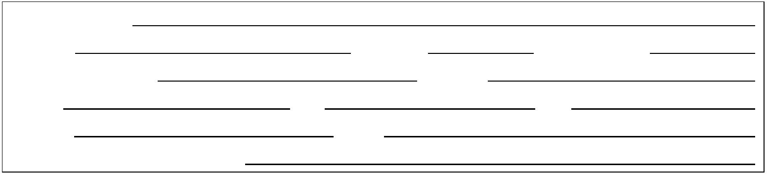

Signature & Stamp:
HEIE 2025 Target Visitors Programme
Exhibitor Name
Website
Company Profile
Products & Technology to be
Showcased
What kind of companies you
are keenly interested in
meeting at HEIE 2025?
Please name some
companies you haven’t
established business
relations but hope to meet at
HEIE 2025 (the more the
better).
Please name some
companies you are already in
cooperation with and hope
to meet at HEIE 2025 (the
more the better).
Note: If the companies you would like to meet are giants like CNPC, SINOPEC, etc. Please name the branch name,
departments or main business.
2


